CIRCLE

<___question>

Type=1

<_block>

Which of these is the exact value of *a* ?

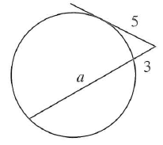

<_block>

[A] *a = 4 $\frac{1}{3}$*

<_block>

[B] *a = 4 $\frac{2}{3}$*

<_block>

[C] *a = 5 $\frac{1}{3}$*

<_block>

[B] a *= 5 $\frac{2}{3}$*

<_block>

[C]

<___question>

Type=1

<_block>

What is the name given in the shaded section ?

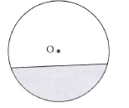

<_block>

[A] $k=-3$ major sector

<_block>

[B] minor sector

<_block>

[C] major segment

<_block>

[D] minor segment

<_block>

[D]

<___question>

Type=1

<_block>

Which of these is the value of *a* ?

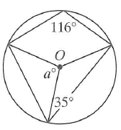

<_block>

[A*] a - 58*

<_block>

[B] *a = 70*

<_block>

[C] *a = 112*

<_block>

[D] *a = 122*

<_block>

[D]

<___question>

Type=1

<_block>

*P, Q* and *R* are points on a circle centre *0*, where *PQ II 0R.*

*If ∠ QP0 = 68º, which of these is the size of ∠* PQR *?*

<_block>

[A] $k=-3$ 22º

<_block>

[B] 68º

<_block>

[C] 112º

<_block>

[D] 124º

<_block>

[D]

<___question>

The opposite angles in a cyclic quadrilateral are

(*3x + 20*)º and (*2x + 60)*º. What is the value of *x* ?

<_block>

[A] *x = 20*

<_block>

[B] *x = 30*

<_block>

[C] *x = 40*

<_block>

[D] *x = 60*

<_block>

[A]

<__question>

Type=1

<_block>

Which of these is the value of *s ?*

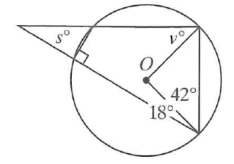

<_block>

[A*] s = 30*

<_block>

[B] *s = 38*

<_block>

[C] *s = 42*

<_block>

[D] *s = 48*

<_block>

[A]

<___question>

Type=1

<_block>

Which of these is the size of ∠ *YTZ?*

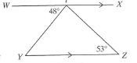

<_block>

[A] 48º

<_block>

[B] 53º

<_block>

[C] 79º

<_block>

[D] 101º

<_block>

[C]

<___question>

Type=1

<_block>

Which test is used to prove ▲*WZS III ▲YXS* ? 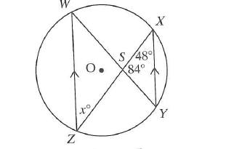

<_block>

[A] 2 sides in proportion and included ∠ equal

<_block>

[B] 3 sides in proportion

<_block>

[C] 2 sides parallel

<_block>

[D] 2 angles equal

<_block>

[D]

<___question>

Type=1

<_block>

If *AC* and *BD* are straight lines, which test is sued to prove

▲*ADO = ▲CBO* ?

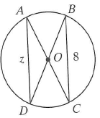

<_block>

[A] AAA

<_block>

[B] AAS

<_block>

[C] SSS

<_block>

[D] SAS

<_block>

[D]

<___question>

Type=1

<_block>

Which of these is the value of *p & q* *?*

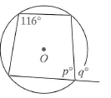

<_block>

[A] p = 58 and q = 104

<_block>

[B] p = 64 and q = 116

<_block>

[C] p = 104 and q = 106

<_block>

[D] p = 84 and q = 112

<_block>

[B]